
Indoor PIR Motion Sensor Outdoor Tri-Tech Motion Sensor Magnetic Contact
Micro Switch Window Barrier Glass Break Detector Panic Switch

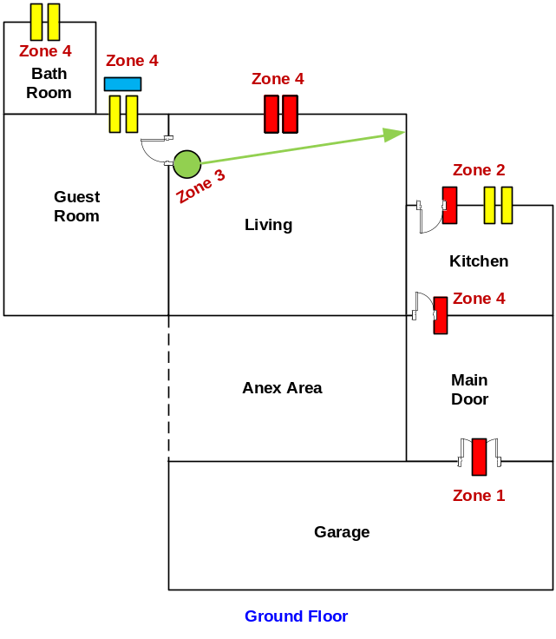

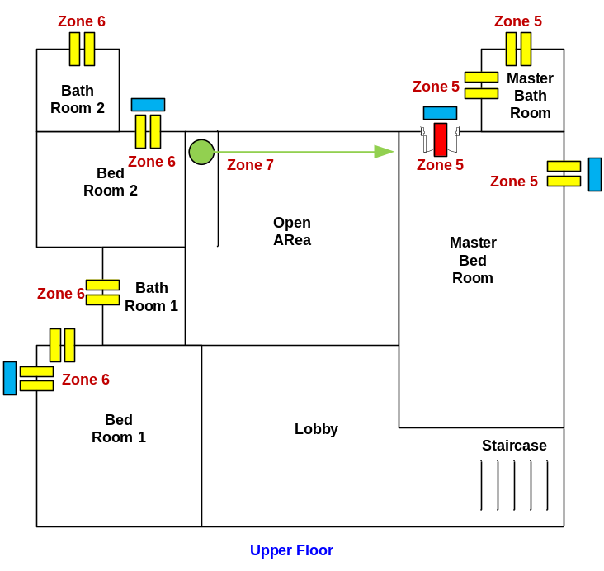

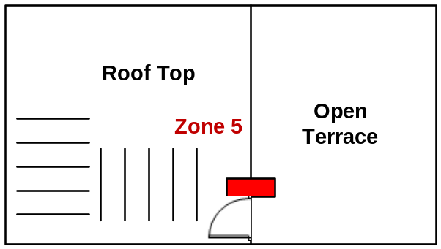

Customer Name | Mr. V. Indra Hemachandra
Drawing Title | IDS
Issue No | 336-14
Issue Date | 9/10/2014
Revision No | 336B-14
Revision Date | 1/11/2014
Created By | Ajith Fernando
Approved By

